Chapter 8, Solution 34.

Calculate i(t) for t > 0 in the circuit in Fig. 8.82.

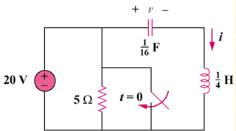
50u(–t) V

5 Ω

Figure 8.82
For Prob. 8.34.

Solution

Before t = 0, the capacitor acts like an open circuit while the inductor behaves like a short circuit.

i(0) = 0, v(0) = 50 V

For t > 0, the LC circuit is disconnected from the voltage source as shown below.

(¼) H

(1/16)F

i
+ −

V_{x}

This is a lossless, source-free, series RLC circuit.

- = R/(2L) = 0, ω_{o} = 1/ = 1/ = 8, s = ±j8

Since α is equal to zero, we have an undamped response. Therefore,

i(t) = A₁cos(8t) + A₂sin(8t) where i(0) = 0 = A₁

di(0)/dt = (1/L)v_{L}(0) = –(1/L)v(0) = –4x50 = –200

However, di/dt = 8A₂cos(8t), thus, di(0)/dt = –200 = 8A₂ which leads to A₂ = –25

Now we have i(t) = –25sin(8t) A

